**MIDDLE EAST TECHNICAL UNIVERSITY**

**DEPARTMENT OF ELECTRICAL & ELECTRONICS ENGINEERING**



**TROY TECH**

**WEEKLY REPORT #1**

**14.02.2019-21.02.2019**

**Section :** 7

**Studio Coordinator:** Mustafa Mert ANKARALI

**Partners :**

Hasan ÖZKARA - 2031888

Kağan ÖZASLAN - 2031854

Caner POTUR - 2031250

Mustafa Ercan OKATAN - 2031193

Mert KAYIŞ – 2030997

**Progresses for Previous Week:**

* We came together and discussed about what we did on Semester Break.
* We wrote Semester Break Progress Reports. In these reports, we stated that what we have done after presentations until today. They include both individual and group progress.
* We discussed about field size and robot size.
* We ordered power amplifier to increase our video transmission range.

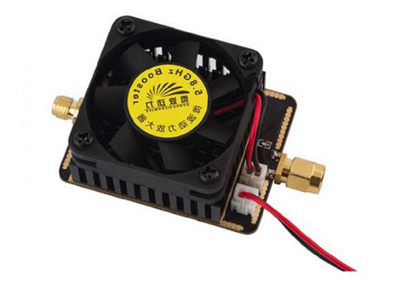

**Plans for the Next Week:**

* We will order and test some products for shooting system(i.e. solenoid systems and spring systems)

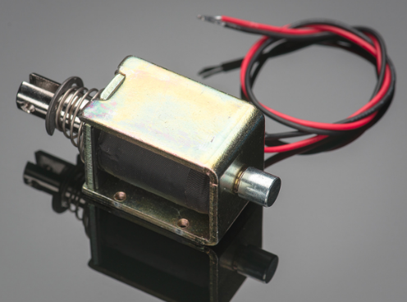

* We will order and test Omni-wheels

